**Report**

|  |  |
| --- | --- |
| Date | 04 Oct 2025 |
| Name | Muhammad Yasir |
| Team ID | PNT2022TMIDxxxxxx |
| Project Name | Power BI Inflation Analysis: Journeying Through Global Economic Terrain |
| Maximum Marks | 5 Marks |

## Introduction

A report is a comprehensive document that provides a structured account of data analysis, findings, and insights. It is typically used for in-depth analysis, documentation, and communication of results. Reports are suitable for decision-makers, analysts, and stakeholders who need a clear understanding of data trends and performance.

This report has been developed in **Power BI**, connecting to Data Source, applying data transformation steps, and creating interactive dashboards to highlight key insights.

## Report Design Process

Designing the report involved the following steps:

1. **Connecting to Data Sources** – Imported datasets (e.g., World Inflation Data 1980–2024).
2. **Data Transformation** – Cleaned missing values, standardized formats, and created calculated columns (e.g., distribution categories).
3. **Modeling** – Built relationships between Fact tables (Inflation data) and Dimension tables (Country, Year, Region).
4. **Visualizations** – Developed visuals such as line charts, bar charts, and pie charts to represent data.
5. **Formatting & Interactivity** – Applied slicers (Year, Region, Category), tooltips, and consistent color formatting for clarity.
6. **Page Organization** – Structured report into multiple pages (Overview, Country Analysis, Time Trends, Regional Insights).
7. **Iteration** – Refined design based on feedback to ensure usability and clarity.

**Report Pages & Insights**

### Overview Page

* **Purpose**: Provide a global snapshot of inflation trends.
* **Visuals Included**:
  + Global average inflation trend (Map chart).
  + Inflation distribution by Region (bar chart).
* **Observation Example**: Venezuela accounts for **58.18% of global inflation sum**, making it the outlier compared to Argentina (12.4%) and Zimbabwe (9.2%).

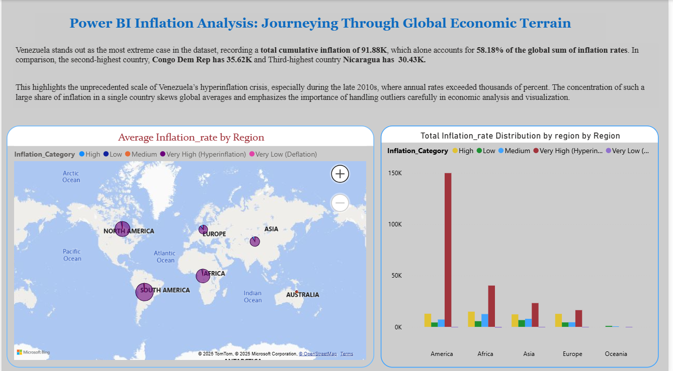

### Country Page

* **Purpose**: Drill down into specific country-level insights.
* **Visuals Included**:
  + Top 5 highest and lowest countries by average inflation (bar chart).
  + Individual country inflation trend (line chart).
  + Distribution category assigned (High/Medium/Low).
* **Observation Example**: Countries like Germany and Japan consistently remain in the **Low Inflation** category, while Venezuela shows extreme volatility.

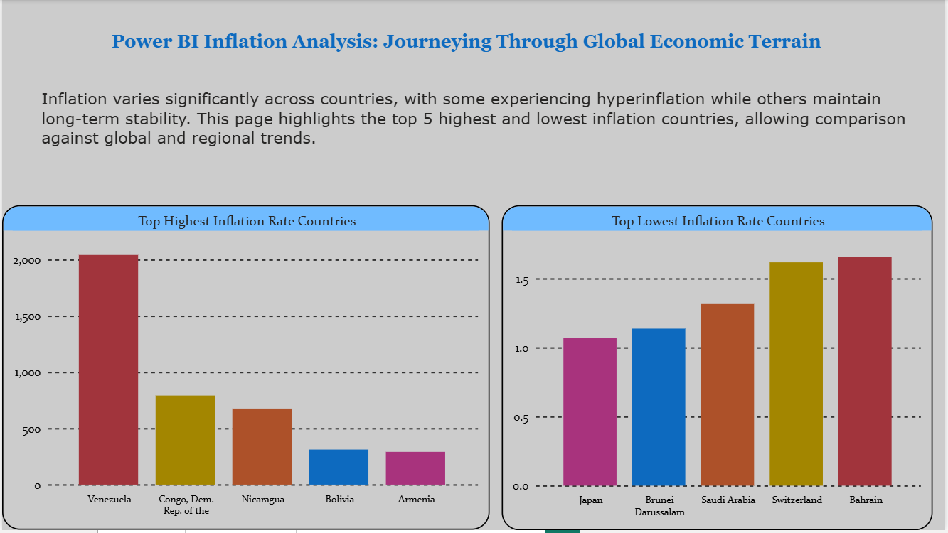

### Time Page

* **Purpose**: Show how inflation evolves over decades.
* **Visuals Included**:
  + Inflation change by decade (line chart).
  + Distribution of categories by decade (stacked column chart).
  + Regional inflation trends by decade.
* **Observation Example**: The **1980s and 1990s** had the highest inflation volatility, with Latin America leading, while the 2010s remained comparatively stable.

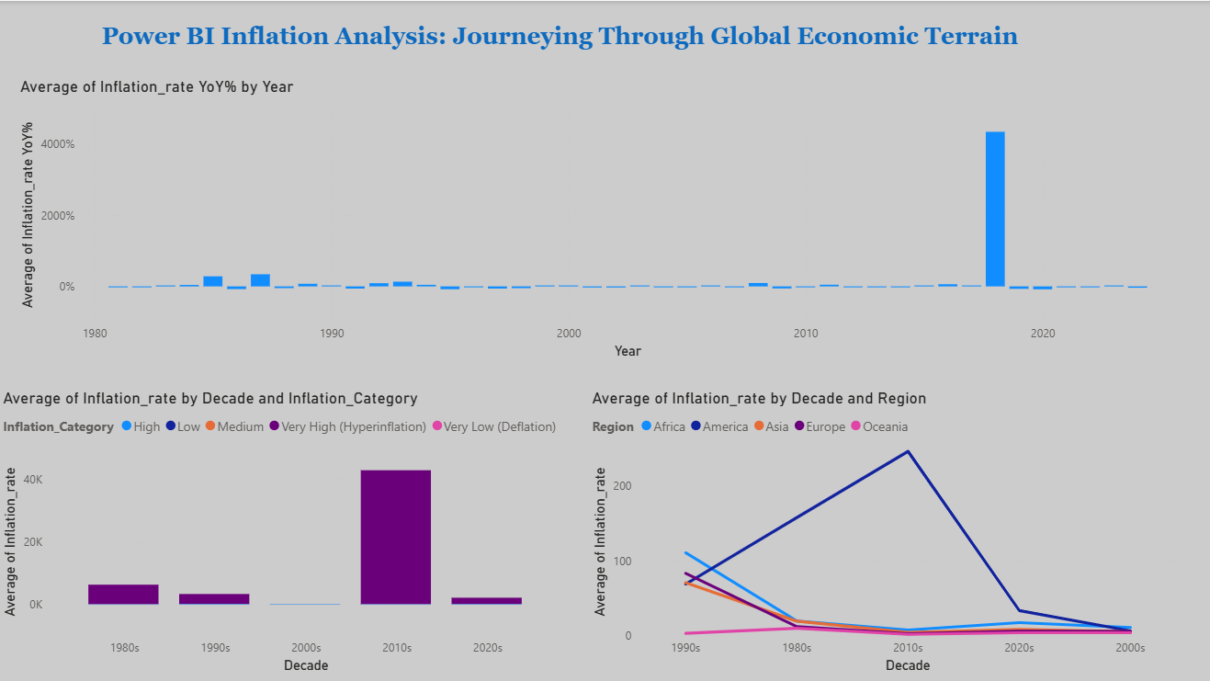

## Key Observations

1. **Trends Over Time**
   * Global inflation peaked in the late 1980s and during the 2008 financial crisis.
2. **Regional Comparison**
   * Latin America contributes most to global volatility, while Europe maintains low, stable inflation rates.
3. **Top Performers vs. Outliers**
   * Countries like Switzerland and Singapore show remarkable stability.
   * Venezuela, Argentina, and Zimbabwe account for the majority of extreme inflation.
4. **Distribution Insights**
   * ~60% of countries fall in the **Low/Moderate Inflation** range across decades, but ~10% consistently remain in the **High/Very High** category.

**Conclusion**

The Power BI report highlights inflation’s uneven distribution across regions and decades, showing both global stability trends and extreme outliers. The insights can help policymakers, economists, and researchers understand historical inflation behaviors and prepare for future scenarios.